Morgan Bronson

March 18th, 2022

Technical Report Week 11

Introduction: This week we learned about spatial interpolation of points which is basically the statistical analysis of measured points to determine measurements of nearby, unmeasured values. For this challenge, we will use different interpolation methods like kriging and IDW to determine the elevation of a single unmeasured point.

Data Used: Wells_SE_Idaho.csv (Idaho Department of Water Resources)

Methods:

* Kriging: I used the kriging tool because I wanted to know what the difference was going to be between a geostatistical tool and a deterministic one. Turns out that the kriging tool is pretty accurate, especially if you optimize the model. I was kind of hesitant to use this tool just because there’s a lot of input that can influence the output, but the optimization key is really helpful.
* IDW: I wanted to use this tool because I figured that the distances between the points would have an influence in the change of elevation. I also wanted to know what the output of this tool would look like because I know how flat Southeastern Idaho is and it’s interesting to learn more about the geology of your hometown.
* Local Polynomial Interpolation: I initially had used the Global Polynomial Interpolation because I remember from the professional memo exercises how smooth and aesthetically pleasing the output layer turned out, but then I was reading about the differences between them and found out that Local Polynomial Interpolation is more accurate (although still inexact) than Global Polynomial Interpolation.

Conclusion: I really enjoyed doing this challenge and I think a lot of it stems from the fact that I’m really familiar with the area so that adds another element of interest for me in the assignment. I thought it was really interesting that the kriging tool and the local polynomial interpolation tools had almost the same exact same output, down to the numbers, but the gray line on the cross validation chart for the local polynomial interpolation was pretty off whereas the gray line for kriging was almost spot on. On the other hand, the gray line for the IDW interpolation was almost as close as the kriging was, but there’s a decent difference in the how the predictions are displayed for both tools. I think this just emphasizes the fact that there’s certain criteria that each tool will perform better under. It was really neat to compare each of the outputs and the statistics for each.

Map: I just included my map for the IDW output because I liked it the best. What I didn’t like about the kriging and local polynomial interpolation outputs is that the elevations came out too smooth, so this one I thought best represented the data.

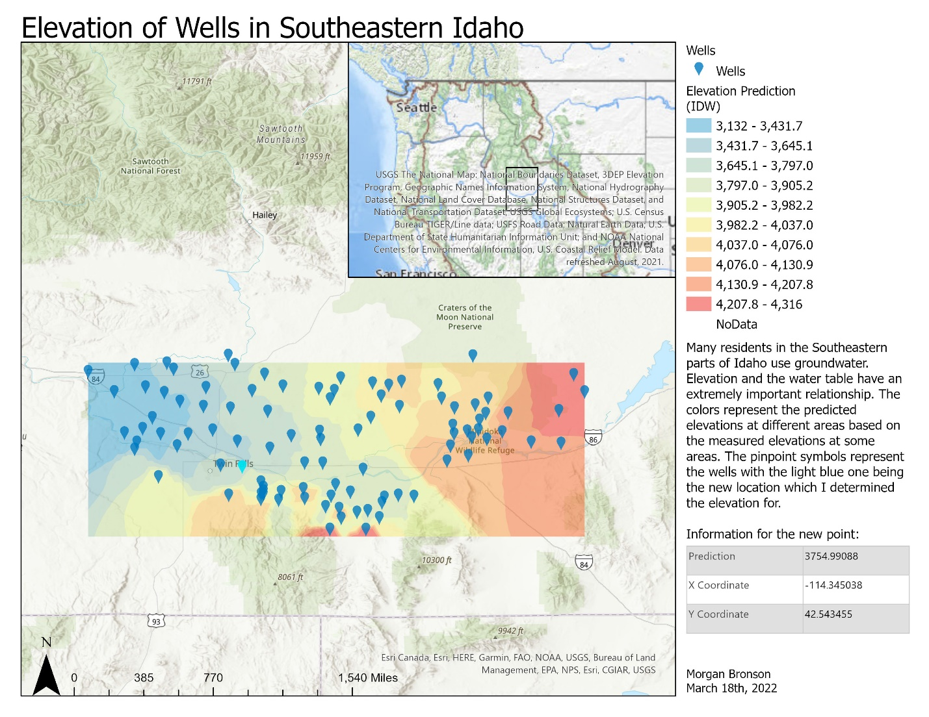

Variables for new point:

|  |  |
| --- | --- |
| Prediction | 3754.99088 |
| X Coordinate | -114.345038 |
| Y Coordinate | 42.543455 |